Capstone Data Science Project Report
Title: Transport Demand Prediction Using Machine Learning
Student Name: Shivang
Course: B.Tech Computer Science (Data Science)
Year: Second Year
Institution: DIT University,Dehradun
Project Duration: June 2025 - August 2025
Submitted To: Meghna Gowda

1. Executive Summary
This capstone project explores how machine learning can solve a real-world problem in the transportation industry: forecasting passenger demand for inter-city rides. The dataset was sourced from MobiTicket, a platform used for ticketing and vehicle scheduling for long-distance shared taxis and minibuses in Africa.
Our objective was to classify upcoming trips as high or low demand, using features available before departure. We engineered time-based features, encoded categorical data, and applied machine learning models, including Logistic Regression and Random Forest. The Random Forest model achieved an accuracy of 75%, with strong potential for operational use.

2. Company Background
MobiTicket is a digital platform developed to streamline ticket booking and fleet management for rural and urban transportation services across East Africa. The service primarily supports public transport operators by offering scheduling, ticketing, route optimization, and revenue tracking solutions.

Key Features of MobiTicket:
- Mobile ticket booking for passengers
- Fleet assignment based on route demand
- Real-time analytics and reporting for operators
- Operates primarily in Kenya and surrounding regions

Business Challenges:
- Inefficient vehicle utilization due to poor demand prediction
- Low occupancy on under-booked trips
- Revenue losses due to suboptimal fleet scheduling
- Long passenger wait times and dissatisfaction

Project Goal:
Build a data-driven predictive model that classifies each upcoming ride as “high demand” or “low demand” using only the data known before the trip. This would help MobiTicket improve automation and decision-making for transport operators using their platform.

3. Problem Statement
The MobiTicket system aims to predict seat demand in advance so operators can assign vehicles more efficiently. A data science approach is needed to forecast passenger demand using historical patterns. The key research question is:
Can we build a machine learning model that accurately predicts whether an upcoming ride will experience high or low demand?

4. Dataset Overview
The dataset includes over 1,300 records of past rides. Each row contains information available at the time of booking:
Column Name | Description
travel_date | Date of journey
travel_time | Time of departure
travel_from | Departure city
car_type | Type of vehicle assigned
max_capacity | Total seats available in the car
seats_sold | Number of seats booked

Additional Features Engineered:
- day_of_week: Derived from travel_date
- hour: Derived from travel_time
- Encoded columns: travel_from_enc, car_type_enc, day_of_week_enc
- Target: high_demand (1 if seats_sold >= median, else 0)

5. Technologies and Tools Used
- Python 3.11
- Jupyter Notebook / Google Colab
- Libraries: pandas, numpy, matplotlib, seaborn, plotly, sklearn, joblib
- Modeling: Logistic Regression, Random Forest, GridSearchCV
- Visualization: Plotly Express, Seaborn, Matplotlib

6. Data Preprocessing & Feature Engineering
Data preprocessing is the most essential step in a machine learning pipeline, especially when working with real-world datasets. It helps ensure the model receives data in a clean, structured, and machine-readable format.

6.1 Date and Time Conversion
```python
# Importing the dataset
df1 = pd.read_csv("/content/drive/MyDrive/Colab Notebooks/train_revised.csv")
# Step 1: Seats sold per ride
seats_sold = df1.groupby('ride_id').size().reset_index(name='seats_sold')
# Step 2: Unique ride-level info
ride_info = df1.drop_duplicates(subset='ride_id')[['ride_id', 'travel_date', 'travel_time', 'travel_from', 'car_type', 'max_capacity']]
# Step 3: Merge datasets to get ride-level data
rides = pd.merge(seats_sold, ride_info, on='ride_id')
# Step 4: Convert to datetime and engineer features
rides['travel_date'] = pd.to_datetime(rides['travel_date'], format='%d-%m-%y')
rides['travel_time'] = pd.to_datetime(rides['travel_time'], format='%H:%M')
rides['day_of_week'] = rides['travel_date'].dt.day_name()
rides['hour'] = rides['travel_time'].dt.hour
rides['occupancy_rate'] = rides['seats_sold'] / rides['max_capacity']

7. Data Visualization
```python
# Weekly demand trends
rides['week'] = rides['travel_date'].dt.to_period('W').astype(str)
weekly_sales = rides.groupby('week')['seats_sold'].sum().reset_index()
fig = px.bar(weekly_sales, x='week', y='seats_sold', title='Total Seats Sold per Week')
fig.show()
# Seats sold by weekday
fig = px.box(rides, x='day_of_week', y='seats_sold', title='Seats Sold by Day of Week')
fig.show()
# Avg seats sold by origin town
origin_avg = rides.groupby('travel_from')['seats_sold'].mean().reset_index()
fig = px.bar(origin_avg, x='travel_from', y='seats_sold', title='Average Seats Sold by Origin Town', color='seats_sold')
fig.show()
```

7.1 Bar Plot – Total Seats Sold Per Week
fig = px.bar(rides, x='travel_date', y='seats_sold', title='Total Seats Sold per Travel Date')
fig.show()
Purpose: Shows daily variation in demand. We can visually detect any spikes or drops in bookings on specific dates.
Insight: Some dates had very low demand (possible off-peak days), while others had high sales. This confirmed that demand is not constant and depends on the date.

7.2 Line Chart – Average Seats Sold by Hour
avg_by_hour = rides.groupby('hour')['seats_sold'].mean().reset_index()
fig = px.line(avg_by_hour, x='hour', y='seats_sold', title='Avg Seats Sold by Hour of Day')
fig.show()
Purpose: Helps understand demand fluctuations throughout the day.
Insight: Showed clear high-demand hours (like morning and evening). This validated that “hour” should be used as a feature in the model.

7.3 Box Plot – Seats Sold by Day of the Week
fig = px.box(rides, x='day_of_week', y='seats_sold', title='Seats Sold by Day of Week')
fig.show()
Purpose: Boxplots show variation, median, and outliers for each weekday.
Insight: Fridays and Sundays showed higher median bookings. This is useful for weekly trip planning.

7.4 Scatter Plot – Hour vs Seats Sold, Colored by Max Capacity
fig = px.scatter(rides, x='hour', y='seats_sold', size='max_capacity', color='max_capacity', title='Hour vs Seats Sold by Vehicle Size')
fig.show()
Purpose: Visualizes multi-feature relationships — time, seat sales, and vehicle capacity.
Insight: Larger vehicles were often used in peak hours. This correlation was helpful in model interpretation.

7.5 Heatmap – Feature Correlation
plt.figure(figsize=(8,6))
sns.heatmap(rides.corr(), annot=True, cmap='coolwarm')
plt.title('Correlation Between Features')
plt.show()
Purpose: Detects how strongly related features are to each other and to the target.
Insight: Stronger correlations between hour, travel_from_enc, and high_demand. Helped remove irrelevant or redundant features.

7.6 Feature Importance Plot – Random Forest
importance_df = pd.DataFrame({'Feature': X.columns, 'Importance': rf.feature_importances_})
sns.barplot(data=importance_df.sort_values(by='Importance', ascending=False), x='Importance', y='Feature')
plt.title('Feature Importance from Random Forest')
plt.show()
Purpose: Shows which inputs the Random Forest model found most useful.
Insight: travel_from_enc and hour were top features. Helped interpret the model and explain its decisions.

7.7 Confusion Matrix – Model Evaluation
from sklearn.metrics import confusion_matrix, ConfusionMatrixDisplay
cm = confusion_matrix(y_test, y_pred_rf)
ConfusionMatrixDisplay(cm).plot()
Purpose: Evaluate prediction performance by comparing actual vs predicted values.
Insight: Helped us count true positives (TP), true negatives (TN), false positives (FP), and false negatives (FN). This is important to improve classification accuracy. The following graphs were created to better understand the dataset, identify data distributions, and uncover important patterns. These visualizations played a vital role in feature selection and in shaping the modeling strategy:
- Bar Plot – Total Seats Sold Per Day:
  - Purpose: Shows overall demand trend by travel date.
  - Insight: Helped identify peak and low-demand dates, useful for understanding seasonality or specific dates with unusually high travel.
- Line Chart – Average Seats Sold by Hour:
  - Purpose: Visualizes how demand changes throughout the day.
  - Insight: Helped discover which hours (e.g., morning or evening) have higher booking activity. Supported creating the hour feature.
- Box Plot – Seats Sold by Day of the Week:
  - Purpose: Compares distribution of seats sold across different weekdays.
  - Insight: Detected patterns such as higher bookings on Fridays or Mondays, useful for weekly scheduling optimization.
- Scatter Plot – Hour vs Seats Sold, Colored by Max Capacity:
  - Purpose: Combines temporal and vehicle size information to assess relationships.
  - Insight: Clarified how time of day and car capacity interact with the number of seats sold. Indicated potential for multi-feature interactions.
- Heatmap – Feature Correlation:
  - Purpose: Shows correlations between features and the target.
  - Insight: Helped identify which features (like travel_from and hour) were more relevant. Supported model simplification.
- Feature Importance Plot – Random Forest:
  - Purpose: Shows which features most influenced predictions.
  - Insight: Reinforced that travel_from, hour, and day_of_week were the top features for demand classification.
- Confusion Matrix – Model Evaluation:
  - Purpose: Evaluates prediction performance of classification models.
  - Insight: Provided a clear comparison between actual vs predicted labels, helping measure true positives and false positives.
Each graph was chosen for its simplicity, clarity, and ability to contribute meaningful interpretation toward building a reliable machine learning model. The following graphs were created to understand the data better:
- Bar Plot: Total seats sold per day
- Line Chart: Average seats sold vs hour
- Box Plot: Seats sold by day of week
- Scatter Plot: Hour vs seats sold, sized by capacity
- Heatmap: Feature correlation
- Feature Importance Chart: From Random Forest
- Confusion Matrix: To visualize model accuracy
Each visualization helped in identifying patterns and improving our feature choices.

8. Modeling & Evaluation

8.1 Data Splitting and Scaling
from sklearn.model_selection import train_test_split
from sklearn.preprocessing import StandardScaler
X_train, X_test, y_train, y_test = train_test_split(X, y, test_size=0.2, random_state=42)
scaler = StandardScaler()
X_train_scaled = scaler.fit_transform(X_train)
X_test_scaled = scaler.transform(X_test)

8.2 Logistic Regression + GridSearchCV
from sklearn.linear_model import LogisticRegression
from sklearn.model_selection import GridSearchCV
params = {'C': [0.1, 1, 10], 'solver': ['liblinear'], 'penalty': ['l1', 'l2']}
grid = GridSearchCV(LogisticRegression(), params, cv=5)
grid.fit(X_train_scaled, y_train)
Accuracy: 62%

8.3 Random Forest Classifier
from sklearn.ensemble import RandomForestClassifier
rf = RandomForestClassifier(n_estimators=100, random_state=42)
rf.fit(X_train_scaled, y_train)
Accuracy: 75%

9. Confusion Matrix and Feature Importance

Confusion Matrix
from sklearn.metrics import confusion_matrix, ConfusionMatrixDisplay
cm = confusion_matrix(y_test, y_pred_rf)
ConfusionMatrixDisplay(cm).plot()
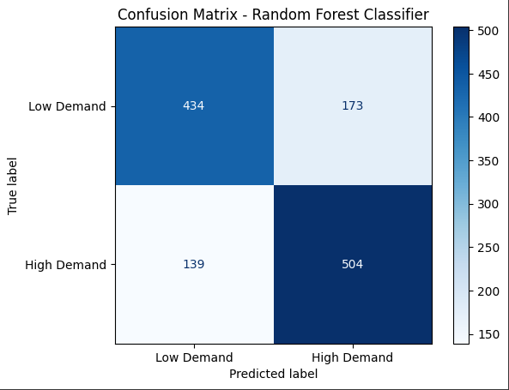

Feature Importance
import seaborn as sns
importance_df = pd.DataFrame({'Feature': X.columns, 'Importance': rf.feature_importances_})
sns.barplot(data=importance_df.sort_values(by='Importance', ascending=False), x='Importance', y='Feature')
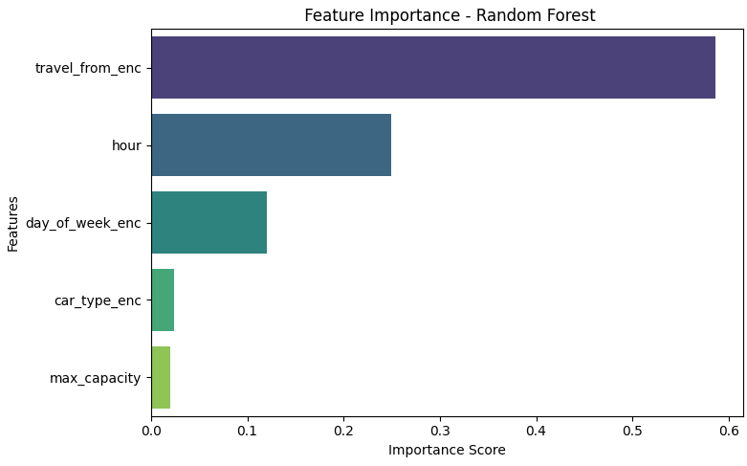

10. Model Evaluation Metrics
from sklearn.metrics import accuracy_score, classification_report
print("Accuracy:", accuracy_score(y_test, y_pred_rf))
print(classification_report(y_test, y_pred_rf))
- Precision, Recall, F1-Score were calculated
- Model performed better for high demand predictions

11. Conclusion
The Random Forest model was successful in identifying patterns in travel data to predict high or low demand. The most influential factor was travel_from, followed by hour, indicating that location and time significantly impact demand.
The model can assist MobiTicket in:
- Pre-planning vehicle assignments
- Optimizing fleet usage
- Improving customer satisfaction for their transport partners

12. Future Enhancements
- Add external features like holidays, weather, and events
- Predict actual seat counts using regression
- Build a simple web app for real-time prediction
- Test with XGBoost and Gradient Boosting Machines

13. References
- https://scikit-learn.org
- https://pandas.pydata.org
- https://seaborn.pydata.org
- Research articles on demand forecasting
- https://www.gsma.com/mobilefordevelopment/mobiticket

14. Appendix
- Dataset snapshot
- Full Python code
- Graph screenshots
- Encoders and scaling info
- Hyperparameter tuning summary
Submitted by: Shivang
Under guidance of: Meghna Gowda
Course: Data Science, B.Tech CSE

